II. United States Historical Climatology Network (US HCN) -
http://cdiac.ornl.gov/epubs/ndp/ushcn/ushcn.html: The United States Historical Climatology Network is a high quality data set of daily and monthly records of basic meteorological variables from 1218 observing stations across the 48 contiguous United States.

- On the home page click on Data Access Web interface Select a state on the pull down menu Click on Map Sites. Many red pins should cover your state. Zoom in to your state until you see the pin closest to your hometown (or use the list of sites) Click on it Click Get Monthly Data

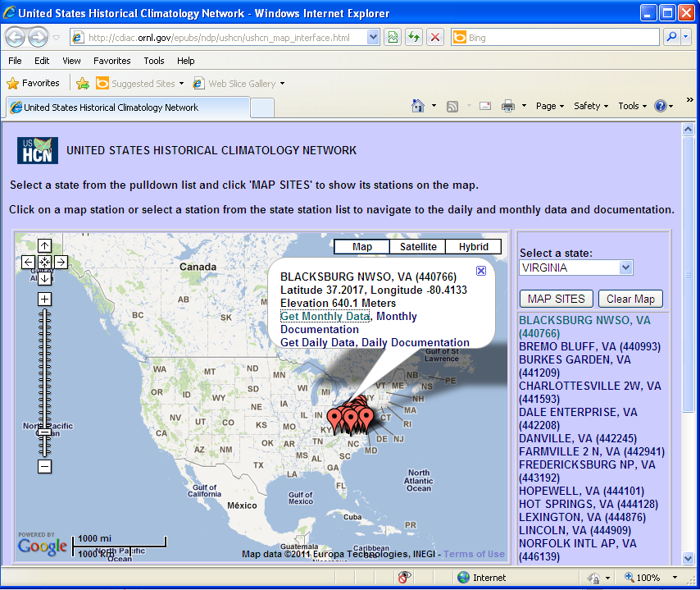

- To create a download file click the link Create a download file of monthly data

- Check the box of the data you want to download Choose the years. Use at least from 1998 until the latest data available. (If you are interested in climate change, you will want to use the entire data set from 1895 if available for your area for your chosen variable Click submit. It may take a minute for your file to be ready if you use the entire data set.

- Click on the link to see your data. It will be for the area you chose from the map, although it is coded ”State_id” in the download. You can select all of the data columns and save them into an empty, open Excel workbook by clicking on the upper left hand cell in the empty Excel workbook.

